<<COURT_NAME>>

|  |  |
| --- | --- |
| <<PROVIDER_SUITNAME>>,  a/a/o <<INJUREDPARTY_NAME>>    Plaintiff,  vs.  <<INSURANCECOMPANY_SUITNAME>>  Defendant.  _____________________________________/ | Case No. <<INDEXORAAA_NUMBER>> |

**NOTICE OF SETTING ACTION FOR JURY TRIAL**

COMES NOW, Plaintiff, <<PROVIDER_SUITNAME>>, by and through undersigned counsel, pursuant to Rule 1.440, Florida Rules of Civil Procedure, and hereby states that this case is at issue and is ready to request that this honorable court set this action for jury trial on the original action. The time estimated for the trial of this matter is three (3) days.

**CERTIFICATE OF SERVICE**

I HEREBY CERTIFY that on February 19, 2022, a true and correct copy of the foregoing was served to all parties registered for this case via the Florida E-filing Portal.

**The Florida Insurance Law Group, LLC**

8724 Sunset Drive, #260, Miami, FL 33173

Tel. (305) 906-4262

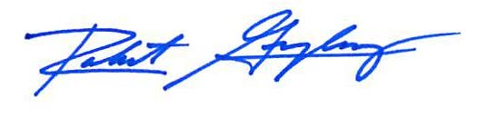

Robert F. Gonzalez, Esq.

Fla. Bar No. 68865

[Pleadings@flinslaw.com](mailto:Pleadings@flinslaw.com)